Python Installation

1. Download Python 3.7 installer and open the .exe file.
   1. DO NOT click install right after opening the .exe file. Check step 2 first.
   2. <https://www.python.org/downloads/>

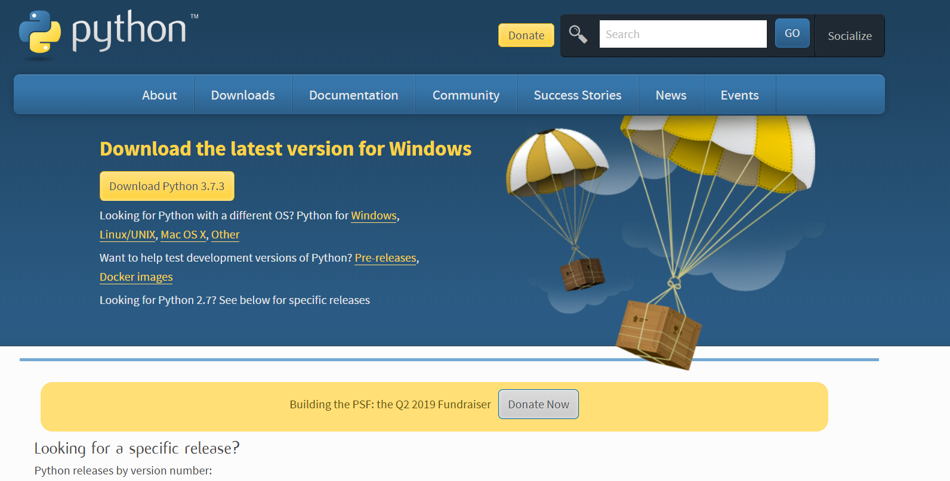

1. During installation, make sure to click the box labelled “Add Python 3.7 to PATH”

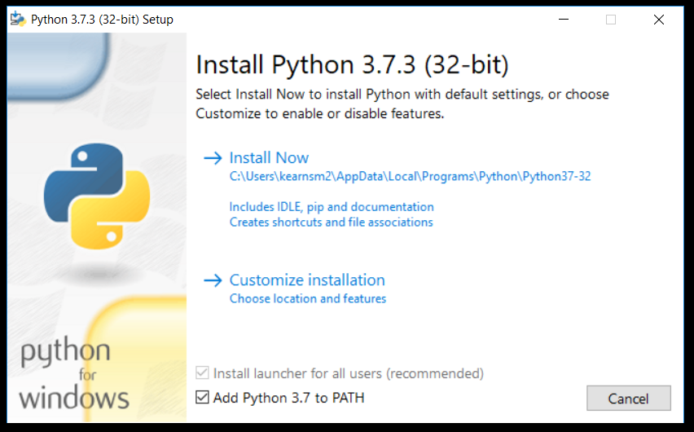

1. Click the “Install Now” option. If prompted to disable the path limit, disable it.
2. After that is installed, open the command prompt by typing “cmd” in the windows search bar on the bottom left of your screen.
3. In the command prompt, type “python”.
   1. This will check to see if python is installed properly. The response should look like the image below.

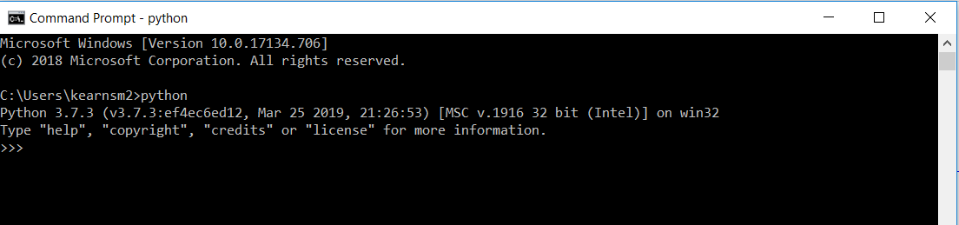

Module/Package Installation

1. 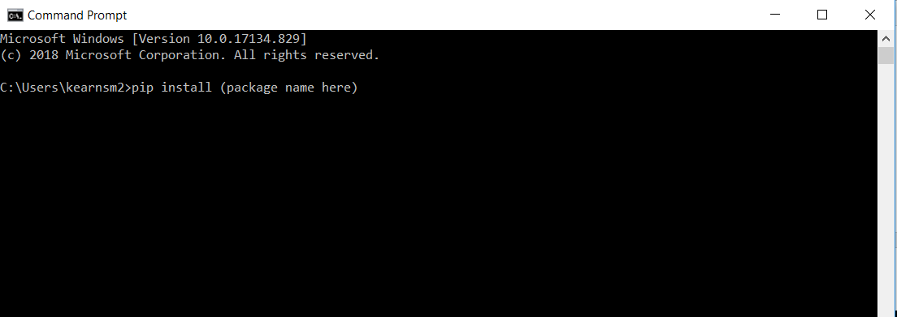Open the command prompt and type “pip install _____” and fill in the blank with the exact name of the package to be installed
2. Do this for all packages required for the script you are using.

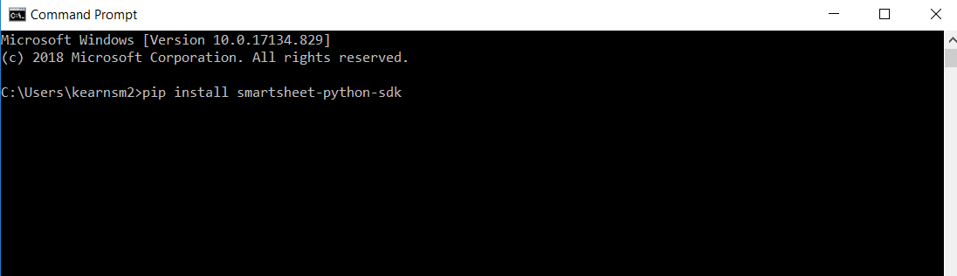Example: Here is an example of installing the package required to work directly with Smartsheets. The name of this package is “smartsheet-python-sdk”